Business Plan  Great Wall  Suburb, QLD | Image / Logo
Submitted by: June March

DATE YEAR

Table of Contents – Great Wall
1 Executive Summary 3
2 Registrations 4
2.1 Proprietors 4
2.2 Company Details 4
2.3 Accountant 4
2.4 Solicitor 4
3 Proprietors’ Background 5
4 Business Profile 5
4.1 Location and Facilities 5
4.2 Key Relationships 6
5 Services 6
6 Marketing 7
6.1 Target Market 7
7 Human Resources 7
8 Operations 8
8.1 Hours of Operation 8
8.2 Lease Details 8
9 Competition 9
9.1 Competitive Advantages 9
10 Funding 9
10.1 Customer Contribution & Funding Need 9
10.2 Security & Other Income Sources 10
11 SWOT Analysis 10
12 Sales Objectives 11
13 Milestones 11
14 Appendix 1 Financial Projections 12
14.1 Sales Projections – Year 1 12
14.2 Cash Flow Forecast – Year 1 13
14.3 Profit and Loss – Year 1 14

Executive Summary
June and Terry March will be the joint owners for the Great Wall which is an established Chinese Restaurant in Suburb. The Great Wall is an ‘a-la-carte’ restaurant currently offering customers an authentic Chinese cuisine within a fixed dinner menu as well as a fully licenced bar service.
The Great Wall will embrace the following marketing activities and believes they will be a key component to its success.
- The Great Wall launch under June and Terry’s ownership.
- Word-of-mouth and customer recommendations will be the most important promotional tool to encourage additional business.
- Local advertising in local newspapers and in the yellow pages.
- Local community businesses will be approached for joint promotions.
- Attending local markets, night markets and cultural events as a stall holder
- Letter box drops of menus to the local community.

The main strengths of the business include:
- High quality authentic and traditional Chinese food.
- Authentic and fully qualified Chinese Chef.
- High quality customer service.
- Owner’s personal involvement in all aspects of the business.
- Proven successful business model and demand from customers.
Year 1 sales revenue is projected at approximately $1.5m with profit projected at over $565k.
This business plan has been written to support an application for $400,000 funding. The funding will mainly be used for the purchase of the business, stock, rent and professional services.

Registrations

Proprietors
Name | June and Terry March
Address | 1 Main Street, Suburb, QLD, 4000.
Telephone | 0400 000 020
Email | June@email.com.au

Company Details

ABN/ACN | 123 123 1234
Business Name/ Address | Great Wall Pty Ltd  Suburban Shopping Centre: 123 Main Rd, QLD, 4000

Accountant

Accountant/Address | Good Accountants: Mr Good  321 Main Rd, Suburb, QLD, 4000
Contact details | 07 0000 0001

Solicitor

Solicitor/Address | A Lawyer  222 Main Rd, Suburb, QLD, 4000
Contact details | 07 0000 8888

Proprietors’ Background
June and Terry March will be the joint owners for the Great Wall restaurant which is an established Chinese Restaurant in Suburb. Terry has had over 10 years experience in the hospitality and food industry, gaining experience and skills in roles such as restaurant management, cooking and various roles within customer service. June has gained valuable customer service and administration experience from her employment in various roles over the past 25 years.

Due to June and Terry’s past industry and employment experience, they have gained the valuable knowledge, experience, skills and industry relationships required to provide quality food and service within the industry. June and Terry pride themselves on their superior customer service and attitude of ‘nothing is too difficult’ in their day to day business. As a result, they can offer the following valuable skills and experience:
- Hospitability and customer service experience and skills.
- Superior customer service.
- Nurturing customer relationships.
- Budgeting, financing and accounting.
- Marketing.
- Human resources.
- Day to day business operations.
- Time management.

Business Profile
The Great Wall is an existing Chinese Restaurant that has been trading for over 20 years under the current owner, who is now looking to sell due to family reasons. In the last financial year, Great Wall achieved approximately $XXX,000 in sales revenue and $XX,000 in net profit. June and Terry will be looking to secure bank funding in order to purchase the Great Wall and commence trading under their ownership by DATE YEAR.
The Great Wall is an ‘a-la-carte’ restaurant currently offering customers authentic Chinese cuisine within a dinner menu as well as bar service. The Great Wall currently operates 5 days a week and is open for a dinner service, as well as offering a takeaway service to customers.
On taking ownership, June and Terry will renovate the Great Wall in order to update the interior and decor, as well as enhancing the current services on offer to include an enhanced catering service, extending the opening hours, and extending the reach of the takeaway service. June and Terry will strive to provide a very unique and personal experience for customers making the Great Wall the restaurant of choice within the target market.

Location and Facilities
The Great Wall is strategically placed within the busy commercial, residential and shopping area of Main Street West in Suburb. The Great Wall is situated in the heart of the city centre in a prime location, providing excellent exposure from all different directions and strong customer foot traffic.

The restaurant boasts a ground floor alfresco dining area for up to 36 customers, as well as a bar area, bathroom facilities and a fully functioning kitchen. The current decor and ambience of the Great Wall is dated as there have been no renovations since the commencement of trading. Therefore, on taking ownership, June and Terry will be updating the decor, fittings and furnishings in order to provide customers with a fresh, welcoming dining experience.

Key Relationships
The following table outlines the key relationships which will aid the Great Wall in its operations.

Name | Nature of Relationship
Current Great Wall customers | Current customers for the Great Wall will continue to provide patronage. In order to cement the strong customer relationships which will help the Great Wall, June and Terry have been working in the restaurant and meeting all of the regular customers.
Various industry relationships | June and Terry will utilise the current relationships that the Great Wall has within the industry for supplier arrangements as well as for potential business.
Mr Owner | Mr Owner has agreed to continue providing business and industry support for June and Terry.
Mr Chef | Mr Chef is a qualified Chinese chef with over 15 years of experience as a Chef. Mr Chef has agreed to work in the Great Wall under the new management.

Services
Currently the Great Wall is only open for a dinner service as well as only providing a takeaway service to a limited range of customers. Upon purchase, June and Terry will be enhancing the current services that the restaurant offers to its customers, as per the following:
- Extending the opening hours to operate 6 days a week.
- Lengthen the restaurant service to include a lunch service as well as a dinner service.
- A range of food including Chinese and local cuisine.
- A fully licensed restaurant including traditional Chinese beers, wines and local beers and wines.
- Catering services to local commercial and residential customers.
- Enhancing the takeaway service to cater to a wider target market rather than just current customers.

Marketing
Great Wall will embrace the following marketing activities and believes they will be a key component to its success.
- A Great Wall launch under June and Terry’s ownership.
- Word-of-mouth and customer recommendations will be the most important promotional tool for encouraging additional business; both through current and potential customers.
- June and Terry will consider creating a website for the Great Wall with information regarding the business as well as the restaurant and bar menu and additional services to customers.
- Local advertising in local newspapers and in the yellow pages. As this has not previously been undertaken this provides a large opportunity for the Great Wall to obtain additional business.
- Local community businesses will be approached for joint promotions.
- Attending local markets and Chinese cultural events as a stall holder
- Letter box drops including a menu to all inner city residents targeting the large young professional individual living in the inner city. It is expected that there will be up to 10,000 menus delivered within a 1 km radius.
- Great Wall has won several culinary awards and the Department of Tourism ‘Recognition of Excellence’ award over the past 20 years. June and Terry will strive to continue winning these awards.

Target Market
Geographically the target market for the Great Wall includes the suburb and surroundings of Suburb, which involves a population of approximately 180,000 people. Of this there are approximately 30,000 people of Chinese origin.

Demographically, the target market includes the local residential and business community as well as visitors, backpackers and all individuals looking for a relaxed dining experience. The target market includes males and females of all ages including families, individuals and couples. The Great Wall caters to any individual who enjoys good food within a comfortable, vibrant and modern venue.

Human Resources
The Great Wall team will be represented by the following organisational chart. It is these staff members that will be instrumental in managing the Great Wall.

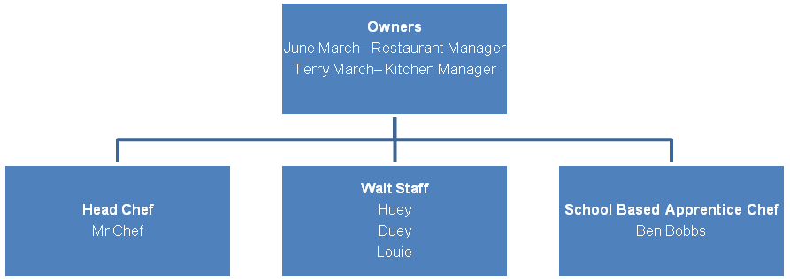
On taking ownership, June and Terry will retain the Apprentice Chef and 2 of the 3 Wait Staff.

Operations
The Great Wall operations consist of the following:
Premises | Equipment | Policies | Hardware | Software
Suburb location | Fridge/freezer | OH&S | Computer | Microsoft office
Fully functioning kitchen | 3 x freezers | Day to day business management | Multi function device | MYOB
Bathroom facilities | 2 x gas cook tops | Responsible service of alcohol | Landline phone | Invoicing and ordering software
Bar area | 4 x electric cook tops | Hygiene and health procedure | Mobile phone
Alfresco dining | Double fryer

Hours of Operation
The Great Wall currently operates 5 days a week for dinner from 5pm to 10pm and is closed on Sundays and Mondays. On taking ownership, June and Terry will be extending the operating hours to include a lunch service as follows:

Day | Hours
 | Lunch |  | Dinner
 | Open | Close | Open | Close
Monday | Closed |  | Closed
Tuesday | 11.00am | 2pm | 5.00pm | 10.00pm
Wednesday | 11.00am | 2pm | 5.00pm | 10.00pm
Thursday | 11.00am | 2pm | 5.00pm | 10.00pm
Friday | 11.00am | 2pm | 5.00pm | 10.00pm
Saturday | 11.00am | 2pm | 5.00pm | 10.00pm
Sunday | 11.00am | 2pm | 5.00pm | 10.00pm

Lease Details
The current lease details for the Great Wall are included below.

Rent | $XX,000 incl GST, per annum paid monthly.
Bond | 2 months rent in advance
Terms | Initial term is for 6 months with view to extending an additional 2 years.
Building size | 100 sqm

Competition
Great Wall is located in the busy commercial, residential and shopping area of Main Street West in Suburb and there are a large number of Chinese and other restaurants in the target market. However, there is no other restaurant that provides such an authentic dining experience in the Suburb area. Great Wall therefore has the unique advantage of having complete access to the target market.

Competitive Advantages
Great Wall believes that it has the competitive advantages of:
- High quality authentic and traditional Chinese food.
- Fully qualified Chinese Chef.
- High quality customer service.
- Owner’s personal involvement in all aspects of the business.
- Proven successful business model and demand from customers.
- Ongoing word-of-mouth and customer recommendations due to strong industry and customer relationships.
- Competitive prices due to strong industry relationships.
- Catering service to local commercial and residential customers.
- Enhanced services including a mobile sushi train and takeaway service available to all customers.

Funding

The following table outlines the funding requirement for this business.

Item | $
Establishment cost (estimate) | 400,000
Marketing material and launch | 20,000
Stock (estimate) | 26,000
Rent deposit (estimate) | 4,500
Rent in advance (estimate) | 4,500
Full operational business plan (estimate) | 10,000
Bank establishment fees (estimate) | 2,000
Working capital | 24,000
Accounting, legal (estimate) | 9,000
Total Investment Required: | 500,000

Customer Contribution & Funding Need

Proprietors will be contributing of $100,000 in cash.
They will seek bank funding for a total of $400,000 in order to commence the business.

Security & Other Income Sources

The following table outlines security available.

Item | $
Residential house estimated value: | 325,000
Borrowings | 145,000
Available Equity | 180,000

SWOT Analysis

Strengths | Weaknesses
High quality authentic and traditional Chinese food.  An authentic and fully qualified Chinese Chef  High quality customer service  Owner’s personal involvement in all aspects of the business  Proven successful business model and demand from customers  Ongoing word-of-mouth and customer recommendations due to strong industry and customer relationships  Competitive prices due to strong industry relationships  Catering service to local commercial and residential customers  Enhanced services including a takeaway service available to all customers  Owner’s professionalism and passion for business success  Strong business values – ethical and honest. | Under funded  Finding and keeping good quality staff
 | Opportunities
Demographics provide a large target market

Opportunity to increase business through enhanced services

No other strong competitors in the target market

 | Threats
Competitors seizing the same opportunity to better service the area

General economic trends

Sales Objectives
Sales forecasts for the first year of trading represent an expected gross annual income of approximately $1.5million with an expected net profit of approximately $565k.

Refer Appendix 1 for financial projections.

Milestones
The following table represents the key milestones the Great Wall will aim to reach in the next 12 months of operation.

Tasks | Time Line
Business Plan | Immediate
Finalise bank funding | Immediate
Finalise purchase of the Great Wall | DATE YEAR
Begin trading under new ownership | DATE YEAR
The Great Wall renovations | DATE YEAR
Staff changes | DATE YEAR
The Great Wall new ownership launch | DATE YEAR
Begin and ongoing marketing activities | DATE YEAR
Analysis of 6 months of trading | DATE YEAR
Analysis of 12 months of trading | DATE YEAR

Appendix 1 Financial Projections

Sales Projections – Year 1
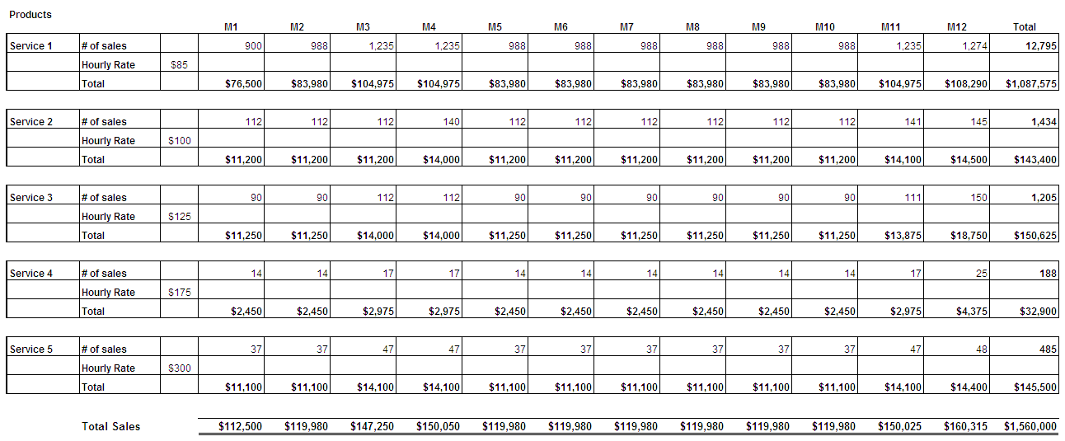

Cash Flow Forecast – Year 1
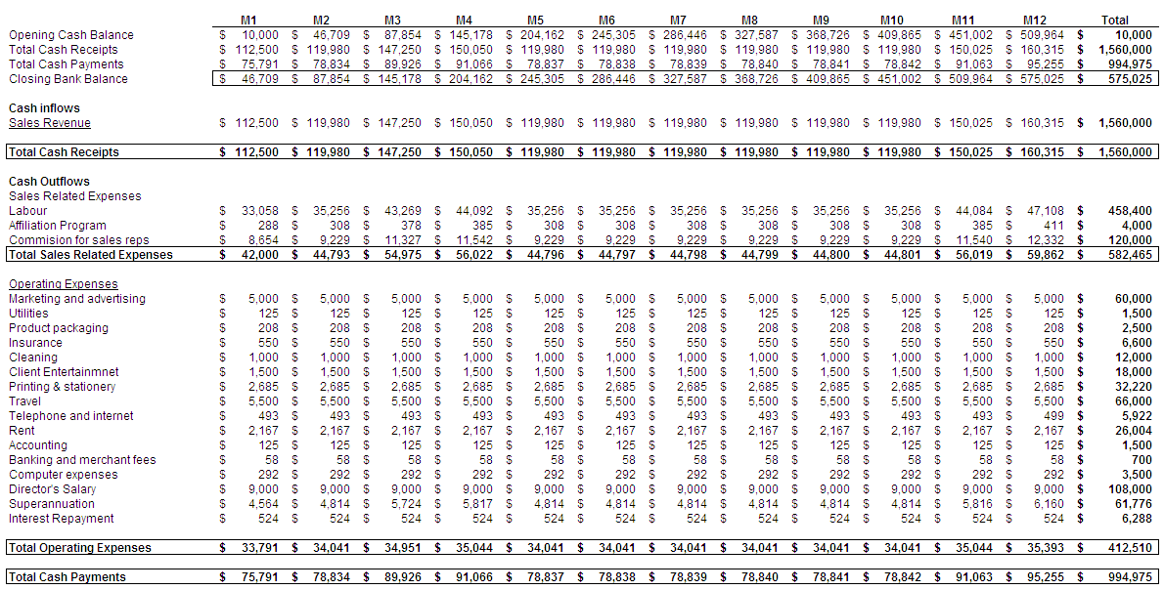

Profit and Loss – Year 1

