Business Plan  Jones & Jones Lawyers  123 Main Street  Suburb  New South Wales, Australia | Logo / Image
Submitted by: John Jones
Month / Year

Table of Contents –Lawyers Business Plan

1 Executive Summary 3
2 Registrations 4
2.1 Proprietors 4
2.2 Company Details 4
2.3 Accountant & Solicitor 4
3 Proprietors’ Background 5
4 Business Profile 6
4.1 Key Relationships 6
5 Products 7
6 Marketing 7
6.1 Target Market 7
7 Human Resources 8
8 Operations 9
8.1 Premises 9
8.2 Hours of Operation 9
8.3 Operational Components 9
8.4 Lease Details 10
9 Competition 10
9.1 Competitive Advantages 11
10 Funding 11
10.1 Customer Contribution & Funding Need 11
10.2 Security & Other Income Sources 11
11 Financial Projections 12
12 SWOT Analysis 12
13 Milestones 13
14 Appendix 1 – Year 1 Financial Projections 14
14.1 Sales Forecast – Year 1 14
14.2 Cash Flow Forecast – Year 1 15
14.3 Profit and Loss – Year 1 16

Executive Summary

John Jones and Jenny Jones will be the owners of Jones & Jones Lawyers a new business which will operate in the Legal Services industry. John has found a premise at 123 Main Road Suburb, which is located at the centre of the busy Suburb retail hub. John will be managing the business on a full-time basis, while Jenny will contribute to the business after hours to allow her to retain her full-time employment in the legal profession.

The inspiration behind Jones & Jones Lawyers came from John’s observation that no legal services businesses were offering customers a full range of solutions to meet their needs. The scope of offering will include criminal law, civil law, IP law, commercial law and pro bono work. There have been businesses that have tried but they generally failed either through low service levels and general customer dissatisfaction.

John believes his years of exposure to the legal services industry, gives him an insight into the workings of the market and a full understanding of what customers are after.

Jones & Jones Lawyers is planning to commence operations in DATE YEAR.

Jones & Jones Lawyers will target individuals, small to medium size businesses in the city and metropolitan area, with a focus on the inner-western suburbs. Jones & Jones Lawyers will embrace the following marketing activities:

- Advertising in local directory papers
- Launching of the Jones & Jones Lawyers website
- Building and maintaining a customer database and send a monthly “Legal Affairs” e newsletters
- Advertising in professional services magazines
- Attending networking groups and events

Key strengths of the business include:

- John has a good name in the industry
- Excellent customer service
- Knowledge of local area and customers
- Location

Year 1 sales revenue is projected at approximately $1.5m with profit projected at over $565k.

This business plan has been written to support an application for $76,000 funding.
The funding will mainly be used for establishment of the business.

Registrations

Proprietors

Name | John Jones and Jenny Jones
Address | 1 Main Street, Suburb, NSW 2000
Telephone | 0400 000 020
Email | John@email.com.au

Company Details

ABN/ACN | 123 123 1234
Business Name/ Address | Jones & Jones Lawyers Pty Ltd  123 Main Rd, Suburb NSW 2000

Accountant & Solicitor

Accountant/Address | Paul Champ Pty Ltd  123 Main Rd, Suburb NSW 2000
Contact details | 02 0000 0001

Solicitor/Address | Jones & Jones Lawyers Pty Ltd  123 Main Rd, Suburb NSW 2000
Contact details | 02 0000 8888

Proprietors’ Background

John Jones and Jenny Jones will be the owners of Jones & Jones Lawyers which is expected to commence trading in DATE YEAR. John will be the working in the business full-time while Jenny will remain working in her current employment.

John has extensive experience in Tier 2 Legal firms and has completed his LLB Qualification.

He is currently working at Keys & Smith Lawyers and is responsible for Individual civil matters. This type of work is his forte. John has also spent almost seven years as a Lawyer at Love Lawyers and has extensive experience in the Legal field.

For most of his working career John has been responsible for setting up and adhering to processes and procedures that ensure an efficient and effective outcome. He has also been responsible for client liaison and ensuring a positive customer experience.

It is his ability to set up processes, improve them and ensure they are adhered to, as well as, his commitment to exceeding customer expectations that will be of great use in his new venture.

Prior to his daughter being born, John worked in the business services and loved dealing with businesses. He has missed this interaction over the years and is sure his personal touch and attention to detail will be a key draw card for repeat business and will generate positive word of mouth in the community.

John has always envisaged he will one day manage his own business, he has always had a passion for tax matters and the Jones & Jones Lawyers opportunity at Suburb is the opportunity he has been waiting for. He will be focusing on his new business 100% and will ensure it is successful and profitable. Furthermore, he is proud to have the opportunity to run a business in the area he lives in and loves.

Jenny Jones has a background in the fashion industry where she spent 8 years working with various designers and labels. Most recently, Jenny has been working towards becoming a qualified Lawyer and has spent the past 3 years working with a local legal practice where she has been helping a number of individual and small businesses.

Business Profile

Jones & Jones Lawyers will be a new business which will operate in the legal services industry. It is the brainchild of John Jones who has worked and been involved in the legal services industry for a number of years. John noticed there was a gap in the market which he believes could prove to be a very lucrative niche.

A premise has come available in main Rd Suburb which would be ideal for the business as it located in the busy retail hub of Suburb.

Jones & Jones Lawyers will offer customers a full range Legal Services including criminal law, civil law, IP law, commercial legal services and pro bono work. The majority of law firms concentrate on providing criminal law, civil law and IP law with very few offering a full service including commercial legal services and pro bono work. The full service that Jones & Jones Lawyers will provide will give customers the opportunity and convenience to source a wide range of legal services solutions from one place.

The main reasons there are very few businesses offering a fuller range to customers is the difficulty in the management of a broad range of offerings, and the issues with delivering a meaningful and consistent message to the target market. John believes his industry experience places him in good stead to successfully manage these potential problems.

Key Relationships

Name | Nature of Relationship
Harry Jones | Harry is good friends of John and Jenny. Harry has owned a number of firms within the Legal Services industry over the years. He has agreed to help and mentor John and Jenny with their business.
Various industry relationships | John and Jenny will utilise all of their current relationships within the industry for supplier arrangements as well as for potential business.
Simon Jones | Simon and Jenny have been friends for a number of years. Simon is the editor of the local newspaper and has agreed to run a story on Jones & Jones Lawyers when it is launched. Simon will inform John of advertising specials and features which Jones & Jones Lawyers could be involved with.
Sarah Jones | Sarah is John’s mother and is a book-keeper. Sarah will be providing casual book-keeping services for the business.

Products

Jones & Jones Lawyers will provide the following products/services.

- Criminal law
- Civil law
- IP law
- Commercial law
- Pro bono work

Charge our rates will vary between $85 per hour and $300 per hour

Marketing

Jones & Jones Lawyers will embrace the following key marketing activities:

- Advertising in local papers
- Launching of the Jones & Jones Lawyers website
- Building and maintaining a customer database and send monthly newsletters
- Home delivery of leaflets covering weekly specials
- Advertising in trade magazines
- Various networking groups and events
- Attending and exhibiting in industry tradeshows
- Yellow pages
- Word of mouth advertising via employees and owners.

Target Market

Jones & Jones Lawyers will target small to medium size businesses in the city and metropolitan area. There are approximately 22,356 small businesses in the area. Jones & Jones Lawyers will concentrate on businesses in the inner-western suburbs and CBD. There are approximately 6,500 target businesses in this area.

Human Resources

John understands the importance of working on the business and not in the business to grow a successful business. To facilitate this John will employ a part-time sales person, and a part-time admin person to assist in operating of the business. This will free up John’s time to concentrate growing the Jones & Jones Lawyers.

Jones & Jones Lawyers’ team is represented in the following organisational chart:

John Jones
Principal
2nd Year Lawyers (2)

Book keeper (1)

Operations

Jones & Jones Lawyers’ operations consist of the following;

Premises

The premises have been leased for 10 years with two 5 year renewal options. The premises are 80 sqm in size and have 40 car parks attached to them.

Hours of Operation

It is intended that the business will trade 5 days per week and closed on public holidays.

Day | Hours
Monday | 9am-5pm
Tuesday | 9am-5pm
Wednesday | 9am-5pm
Thursday | 9am-5pm
Friday | 9am-5pm
Saturday | Closed
Sunday | Closed

Operational Components

Core operational components will comprise of the following:

Equipment | Hardware | Software | Policies
POS System & Scanners | Computers & Server | Microsoft office | OH&S
Standard office furniture | Multi function device | MYOB | Day to day business management
Filing cabinets | Landline phone | Invoicing software
Book cases | Mobile phone | Sales analysis tool

Lease Details

The current lease details are as follows;

Lease commencement date | DATE YEAR
Terms | 7 years (3½ years remaining as at DATE YEAR)
Rent/month | $XX,700 (GST inclusive) per month
Bond | $XX,000 (GST inclusive)

Competition

Jones & Jones Lawyers is located in the extremely busy shopping area of Main Street in Suburb. There are a number of competitors in the target market. In the inner-western suburbs there are other Legal Services businesses all of which provide criminal law, civil law and IP law to the target market. However, the majority of competitors do not provide the range of Jones & Jones Lawyers, and very few provide customers the option of having commercial law and pro bono work in addition to the core business of providing criminal law and civil law services.

The following table provides a breakdown of the main competitors to Jones & Jones Lawyers.

Competitor | Address | Main Products | Competitive Threat
ABC Legal Services | 17 Regent St Suburb | Criminal law, Civil law, IP law, Commercial Legal Services | High
XYZ Legal Services | 116 North St Suburb | Criminal law, Civil law, IP law, Pro bono workfund administration | Medium
High St Legal Services | 1 High St Suburb | Criminal law, Civil law, IP law | Low
Legal Services r us | 23 Railway St Suburb | Criminal law, Civil law, IP law | Low

Competitive Advantages

Jones & Jones Lawyers has the following competitive advantages:

- High quality customer service.
- Owners’ previous skills and industry experience.
- Wide range of products
- Owners’ personal involvement in all aspects of the business.
- Ongoing word-of-mouth and customer recommendations due to strong industry and customer relationships.
- Competitive prices due to strong industry relationships.
- Catering to local customers.

Funding

The following table outlines the funding requirement for this business.

Item | $
Office fit out | 20,000
Marketing material and launch | 10,000
Rent deposit (estimate) | 4,500
Rent in advance (estimate) | 4,500
Professional memberships & licenses | 1,000
Full operational business plan (estimate) | 10,000
Bank establishment fees (estimate) | 2,000
Working capital | 24,000
Total Investment Required: | 76,000

Customer Contribution & Funding Need

Proprietors will be contributing of $25,000 in cash.
They will seek bank funding for a total of $51,000 in order to commence the business.

Security & Other Income Sources

The following table outlines security available.

Item | $
Residential house estimated value: | 325,000
Borrowings | 145,000
Available Equity | 180,000

Financial Projections

Sales forecasts for the first year of trading represent an expected gross annual income of approximately $1.5million with an expected net profit of approximately $479k.

See Appendix 1 – Financial forecasts for year 1.

SWOT Analysis

The following table represents the strengths, weaknesses, opportunities and threats of the business.

Strengths | Weaknesses
John has a good name in the industry  Excellent customer service skills  Knowledge of local area and customers  Location  Brand new renovated premises  Professionalism of staff  Extensive product range | New to market  Key person reliant
 | Opportunities
Filling a niche in a lucrative market

Utilising industry contacts

Replicate the businesses in other appropriate locations

 | Threats
General economic conditions

Competitors matching of the Jones & Jones Lawyers offering

Milestones

The following table represents the key milestones Jones & Jones Lawyers will aim to reach in the period ending DATE YEAR:

Tasks | Time Line
Business Plan | Immediate
Finalise bank funding | Immediate
Finalise lease of premises | Immediate
Employee 2nd Year Lawyers | DATE YEAR
Publicise launch of business | DATE YEAR
Launch business | DATE YEAR
Begin and ongoing marketing activities | DATE YEAR
Analysis of 6 months of trading | DATE YEAR
Analysis of 12 months of trading | DATE YEAR

Appendix 1 – Year 1 Financial Projections
Financials here are samples only and generic by nature, not necessarily related to the products/services of this business plan. Financials here are intended to illustrate lay- out only.

Sales Forecast – Year 1
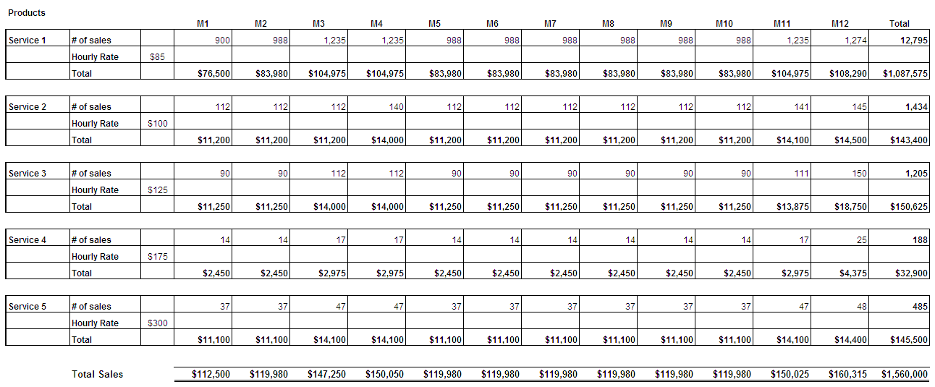

Cash Flow Forecast – Year 1
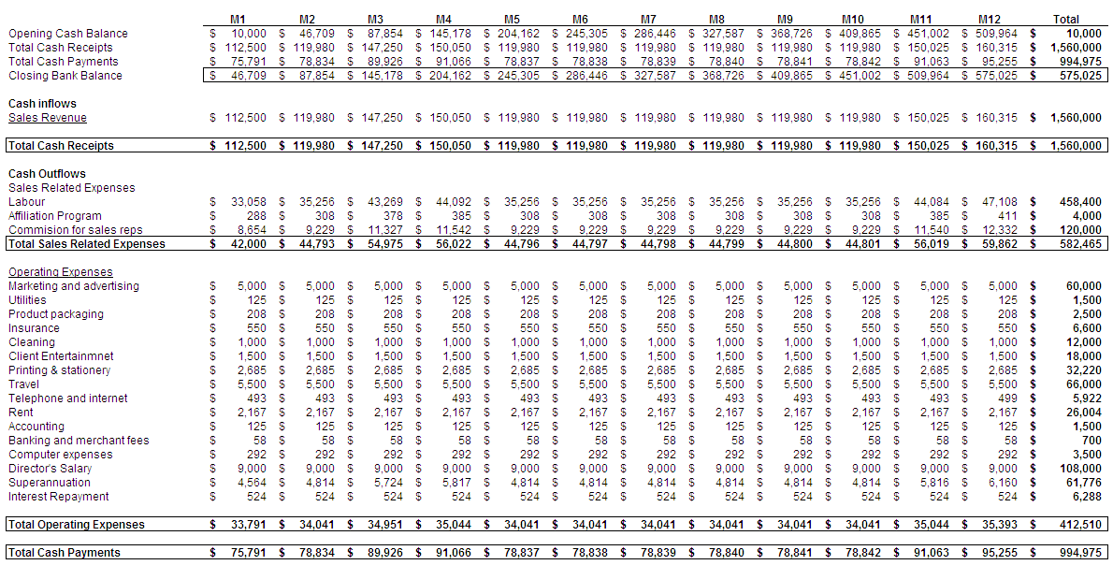

Profit and Loss – Year 1
