Business Plan  John’s Electrical  123 Main Street  Suburb  Victoria, Australia | Logo / Image
Submitted by: John Smith
Month / Year

Table of Contents –Electrician Business Plan

1 Executive Summary 3
2 Registrations 4
2.1 Proprietors 4
2.2 Company Details 4
2.3 Accountant & Solicitor 4
3 Proprietors’ Background 5
4 Business Profile 6
4.1 Key Relationships 6
5 Services 7
6 Marketing 7
6.1 Target Market 7
7 Human Resources 8
8 Operations 9
8.1 Premises 9
8.2 Hours of Operation 9
8.3 Operational Components 9
8.4 Suppliers 10
9 Competition 10
9.1 Competitive Advantages 10
10 Funding 11
10.1 Customer Contribution & Funding Need 11
10.2 Security & Other Income Sources 11
11 Financial Projections 11
12 SWOT Analysis 11
13 Milestones 13
14 Appendix 1 Year 1 Financial Projections 14
14.1 Sales Projections – Year 1 14
14.2 Cash Flow Forecast – Year 1 15
14.3 Profit and Loss – Year 1 16

Executive Summary

John Smith will be the owner of John’s Electrical a new business which will operate in the electrical industry. John will run and manage the business on a full-time basis from his home office in Suburb.

John is establishing John’s Electrical as he believes there is a real opportunity present in the market for good reliable electricians. This is due to the approval of new housing and commercial developments in the northern and outer suburbs of City, and the lack of tradesmen in general but electricians in particular. The scope of offering will include light & power repairs, light & power outlet installations, security lighting, smoke detectors and general electrical maintenance.

John’s many years of experience in the building and electrical industry, gives him an insight into the workings of the industry and he is many valuable building company contacts who have said they would be willing to utilise his services on projects.
John’s Electrical is planning to commence operations in DATE YEAR.

John’s Electrical will be targeting builders of residential developments and the domestic market. John’s Electrical will embrace the following marketing activities:

- Advertising in local papers.
- Launching of the John’s Electrical website.
- Home delivery of leaflets covering services.
- Yellow pages
- Word of mouth advertising via builders

Key strengths of the business include:

- John has a good name in the industry
- Excellent customer service
- Knowledge of local area and customers

Year 1 sales revenue is projected at approximately $210k with profit projected at over $44k.

This business plan has been written to support an application for $40,000 funding.
The funding will mainly be used for the purchase of the business, parts and materials, working capital and professional services.

Registrations

Proprietors

Name | John Smith
Address | 1 Main Street, Suburb, VIC 3000
Telephone | 0400 000 020
Email | John@email.com.au

Company Details

ABN/ACN | 123 123 1234
Business Name/ Address | John’s Electrical Pty Ltd  123 Main Rd, Suburb VIC 3000

Accountant & Solicitor

Accountant/Address | Good Accountants: Mr Good  321 Main Rd, Suburb, VIC 3000
Contact details | 03 0000 0001

Solicitor/Address | A Lawyer  222 Main Rd, Suburb, VIC 3000
Contact details | 03 0000 8888

Proprietors’ Background

John Jones will be the sole owner of John’s Electrical which is expected to commence trading in DATE YEAR.

John has extensive experience in the building and electrical industry roles and has completed the following courses:

- Course A in Electrical Engineering at Training Organisation
- Course B in Electrical Maintenance at Training Organisation
- Course C in Electrical Systems at Training Organisation

He is currently working at Harry’s Electrical. He has been at this job for 3 years working on all types of electrical jobs including light & power repairs, light & power outlet installations, security lighting. John has also spent almost seven years at Bob’s Electrical where he gained extensive experience in smoke detectors and general electrical maintenance.

During his working career John has prided himself on ensuring he has regular communication with the client. To this regard he has set up processes and procedures that ensure an efficient and effective outcome for the client and ensuring a positive customer experience.

It is his ability to set up processes, improve them and ensure they are adhered to, as well as, his commitment to exceeding customer expectations that will be of great use in his new venture.

John has always envisaged he will one day manage his own business and starting John’s Electrical is the opportunity he has been waiting for. He will be focusing on his new business 100% and will ensure it is successful and profitable. Furthermore, he is proud to have the opportunity to run a business in the area he lives in and loves.

John is also a member of the following trade organisations:

- Masters’ Electrician Association
- Australian Association of Electricians
- The Australian Electricians Union

John’s wife Jenny has been working towards becoming a qualified accountant and has spent the past 3 years working with a local accounting practice where she has been helping a number of small businesses. Additionally, Jenny is a graphic designer and will be utilising these skills in creating the Business logo, website and marketing material.

Business Profile

John’s Electrical will be a new business which will operate in the Electrical industry. It is the brainchild of John Smith who has worked and been involved in the industry for a number of years. John noticed there was a gap in the market which she believes could prove to be a very lucrative niche. The business will be operated out of the family home in Suburb.

John’s Electrical will offer customers a full range of electrician services including light & power repairs, light & power outlet installations, security lighting, smoke detectors and general electrical maintenance. John will focus on the area from Suburb to northern and outer suburbs. This region is experiencing massive population growth fueled by the State Government opening up land for housing developments. This feeds into the growth of commercial development as the infrastructure requirements need to be extended to cater for the new growth areas.

There is also a distinct shortage of tradesmen and in particular electricians in the area. This creates bottlenecks in developments and slows down all construction projects which directly impact the developers financially.

John believes John’s Electrical will be in an ideal position to win enough of this type of work to make John’s Electrical a financially. In addition John’s Electrical will target the residential market where there is a constant demand for general electrician services.

Key Relationships

Name | Nature of Relationship
Harry Smith | Harry is good friends of John and Terry. Harry has owned a number of businesses within the industry. He has agreed to help and mentor John and Terry with their business.
Various industry relationships | John and Terry will utilise all of their current relationships within the industry for supplier arrangements as well as for potential business.
Simon Jones | Simon and Terry have been friends for a number of years. Terry is the editor of the local newspaper and has agreed to run a story on John’s Electrical when it is launched. Simon will inform John of advertising specials and features which John’s Electrical could be involved with.
Jenny Jones | Jenny will be providing the book-keeping and accounting services for the Business.

Services

John’s Electrical will provide the following products.

- Light & power repairs
- Light & power outlet installations
- Security lighting
- Smoke detectors
- General electrical maintenance

Marketing

John’s Electrical will embrace the following key marketing activities:

- Advertising in local papers.
- Launching of the John’s Electrical website.
- Building and maintaining a customer database and send monthly newsletters
- Home delivery of leaflets covering its services.
- Yellow pages
- Word of mouth advertising via builders and customers.

Target Market

John’s Electrical will target customer segments:

Trade Market – John’s Electrical will target builders and construction companies to offer its services. There are approximately 22 builders that operate on the northern side of the city that John’s Electrical will target.

Residential Market – John’s Electrical will target the immediate catchment area. There are approximately 2,356 households in the area with an annual income of $42,100 p.a. These households consist mostly of young and single parent families.

Human Resources

John will be seeking to employ an apprentice electrician within the first six months of operation. Depending on the success of the business John may employ another qualified electrician in the second year.

John’s Electrical team is represented in the following organisational chart:

Owner / Manager

John Smith

Apprentice Electrician

Operations

John’s Electrical’s operations consist of the following;

Premises

The business will be operated from a home office out of the family home in Suburb. The home office will be equipped with the necessary computer and office equipment to run the business.

Hours of Operation

It is intended that the business will trade 5 days per week and closed on public holidays.

Day | Hours
Monday | 7am-3pm
Tuesday | 7am-3pm
Wednesday | 7am-3pm
Thursday | 7am-3pm
Friday | 7am-3pm
Saturday | Closed
Sunday | Closed

Operational Components

Core operational components will comprise of the following:

Vehicles & Equipment | Hardware | Software | Policies
Ute | Computer | Microsoft office | OH&S
Various electrician’s tools | Multi function device | MYOB | Day to day business management
 | Landline phone | Invoicing software
 | Mobile phone | Sales analysis tool

Suppliers

John’s Electrical will source its parts and materials from four main suppliers.

- Box Electrical Supplies
- Capital Electrical Supplies
- City Electrical Supplies
- Premium Electrical Supplies

Competition

There are number of small electrician businesses in the market however the current demand in the market far outweighs supply. John’s Electrical believes there is ample work available for all current electrician business to survive and thrive.

The following table provides a breakdown of the main competitors to John’s Electrical.

Competitor | Address | Main Products | Competitive Threat
ABC Electrical | 17 Main St Suburb | Light & power repairs, Light & power outlet installations, Security lighting, Smoke detectors | High
XYZ Electrical | 116 Main St Suburb | Light & power repairs, Light & power outlet installations, Security lighting, General electrical maintenance | Medium
High St Electrical | 1 High St Suburb | Light & power repairs, Light & power outlet installations, Security lighting | Low
Electricians r us | 23 High St Suburb | Light & power repairs, Light & power outlet installations, Security lighting | Low

Competitive Advantages

John’s Electrical believes that it has the competitive advantages of:
- High quality customer service.
- Owners’ previous skills and industry experience.
- Ongoing word-of-mouth and customer recommendations due to strong industry and customer relationships.

Funding

The following table outlines the funding requirement for this business.

Item | $
Establishment cost (estimate) | 15,000
Marketing material | 5,000
Parts and Materials (estimate) | 5,000
Working capital | 15,000
Full operational business plan (estimate) | 10,000
Total Investment Required: | 50,000

Customer Contribution & Funding Need

Proprietors will be contributing of $10,000 in cash.
They will seek bank funding for a total of $40,000 in order to commence the business.

Security & Other Income Sources

The following table outlines security available.

Item | $
Residential house estimated value: | 325,000
Borrowings | 145,000
Available Equity | 180,000

Financial Projections

Sales forecasts for the first year of trading represent an expected gross annual income of approximately $210,000 with an expected net profit of approximately $44,000 after director’s salary, superannuation and loan repayments.

See Appendix 1 – Financial forecasts for year 1.

SWOT Analysis

The following table represents the strengths, weaknesses, opportunities and threats of the business.

Strengths | Weaknesses
John has a good name in the industry  Excellent customer service  Knowledge of local area and customers  Location  Extensive service range | New to market  Key person reliant
 | Opportunities
Filling a niche in a lucrative market

Utilising industry contacts
 | Threats
General economic conditions

Government cancelling or suspending new developments

Multiple competitors entering the market

Milestones

The following table represents the key milestones John’s Electrical will aim to reach in the period ending DATE YEAR:

Tasks | Time Line
Business Plan | Immediate
Finalise bank funding | Immediate
Finalise lease of premises | Immediate
Negotiate supplier terms | DATE YEAR
Start to publicise launch of business | DATE YEAR
Launch business | DATE YEAR
Begin and ongoing marketing activities | DATE YEAR
Analysis of 6 months of trading | DATE YEAR
Analysis of 12 months of trading | DATE YEAR

Appendix 1 Year 1 Financial Projections
Financials here are samples only and generic by nature, not necessarily related to the products/services of this business plan. They are intended to illustrate lay- out only.

Sales Projections – Year 1

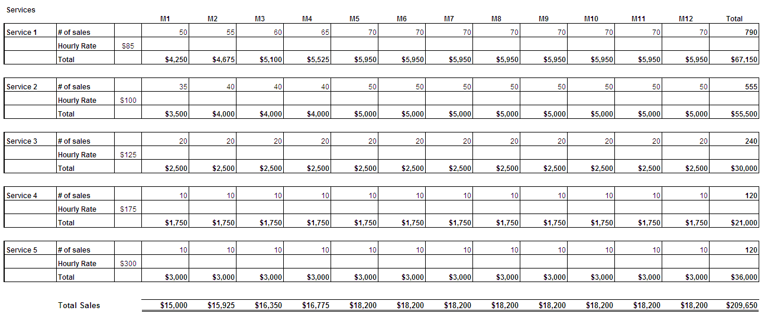

Cash Flow Forecast – Year 1

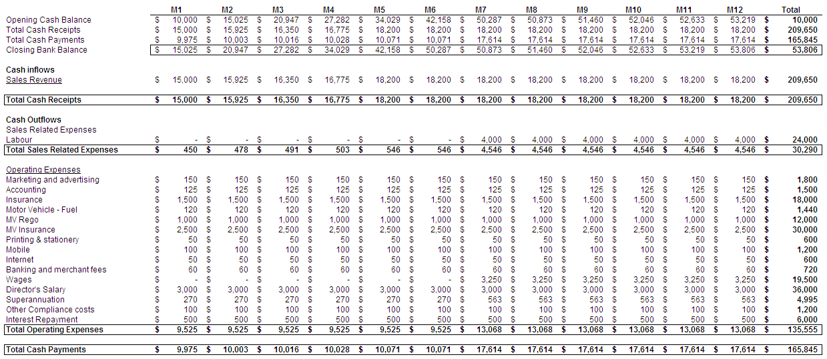

Profit and Loss – Year 1

